Smart Recipe Box & Grocery API
Technical Implementation, Verification, and Architecture Report
Prepared By: Atla Dhatri Sai
Development Framework: FastAPI Asynchronous ASGI Core
Data Infrastructure Module: MongoDB Community Server v7.0
1. Project Description & Outcomes
The Smart Recipe Box & Grocery API is a specialized backend microservice designed to streamline kitchen workflow planning, recipe cataloging, and automated grocery resource management. Traditional applications treat ingredients as unparsed text entities, making it nearly impossible to dynamically scale or consolidate items across multiple dishes. This system resolves data fragmentation by combining an asynchronous Python framework with a schema-flexible document database, establishing data consistency rules and automated operational safety nets.
By designing separate modules—including explicit environment connections, strict schema parsers, business calculations pipelines, and routing layers—the architecture achieves exceptional data safety, ultra-low query times, and production-ready code maintainability. The platform processes complex user instructions, performs in-memory string and volume transformations, and returns unified, category-grouped shopping manifests in real time.
Core Technical Outcomes Reached:
- Dynamic Ingredient Consolidation: Merges duplicate items automatically across independent recipes, keeping your list organized by grocery sections (e.g., Dairy, Produce, Pantry).
- In-Memory Unit Standardization Matrix: Detects differing volumetric fractions (like tablespoons and teaspoons) and normalizes them into a single base metric (cups) before running aggregation algorithms.
- Fault-Tolerant Connection Safeguard Middleware: Intercepts unexpected database outages cleanly via global request inspection loops, ensuring the web application remains live and reporting descriptive service messages instead of freezing.

2. Technical Stack & Workspace Utilities
The architecture relies completely on open-source, production-grade tools engineered to provide robust execution, predictable runtime parameters, and optimal performance profiles.
Tool / Framework Name | Configured Version | Role Within the System Architecture
FastAPI | v0.110.0+ | Asynchronous framework core handling data routing, reflection layers, and OpenAPI generation.
MongoDB Community Edition | v7.0+ | High-throughput BSON document store managing recipes and transactional manifests natively.
Pydantic | v2.0+ | Implements rigorous schema enforcement, protecting endpoints from malformed or dirty data inputs.
Uvicorn Server Process | v0.28.0+ | High-performance ASGI server gateway interface running the core execution event loop.
Postman Client Workspace | v10.24.0+ | Sandbox development utility used for executing endpoint lifecycle integration tests.
MongoDB Compass GUI | v1.42.0+ | Graphical administrative platform utilized to visually audit database record properties.
3. Core Execution Playbook & System Verification Logs
This section outlines the sequential testing path of the application workspace. It includes only the most critical checkpoints, directly connecting each visual log to its technical role within the system backend.

3.1 Application Server Bootstrap Logs
The application loop starts by initializing the Uvicorn ASGI server gateway via the command line interface. The log trail verifies that the web engine maps local folder structures, mounts active system routing paths, and binds to local port 8000 successfully. It monitors files actively to trigger real-time module updates upon saved changes.
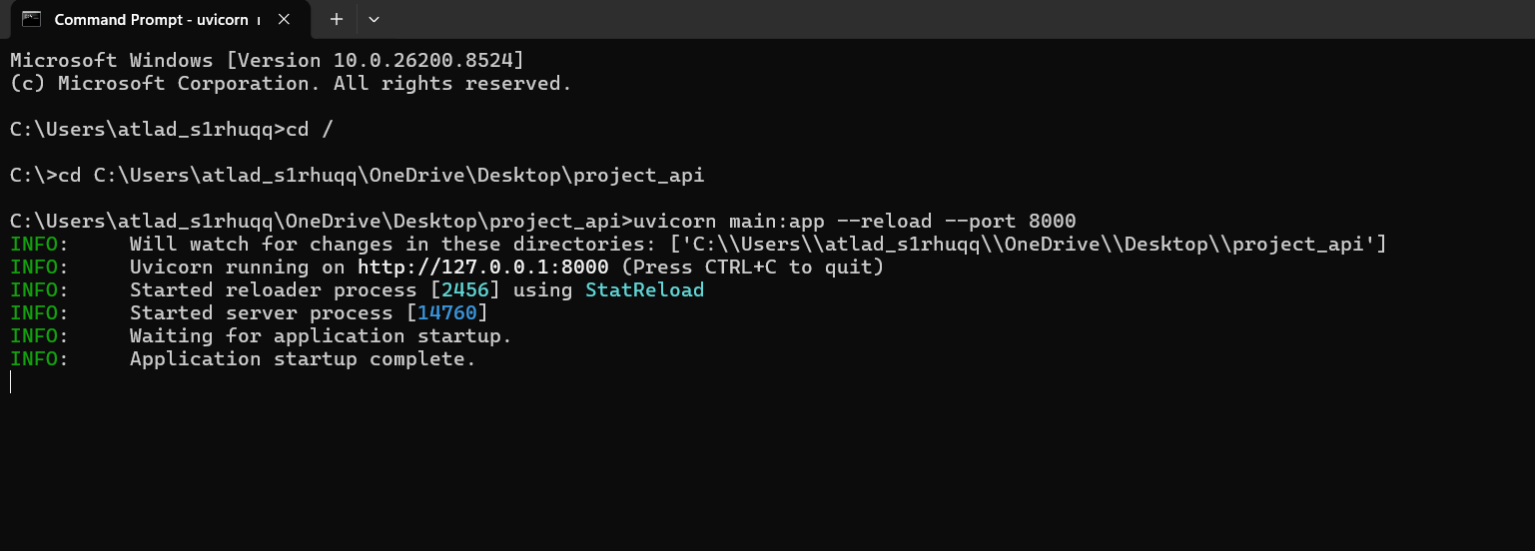 Figure 3.1: Command Line Terminal Logging Successful Uvicorn Application Boot Sequences
3.2 Core OpenAPI Documentation Map
At startup, FastAPI reads parameters from Pydantic schema objects at runtime to automatically build a Swagger OpenAPI documentation dashboard. This centralized UI provides direct, interactive access to all active routes, explicit data models, validation constraints, and response code templates.
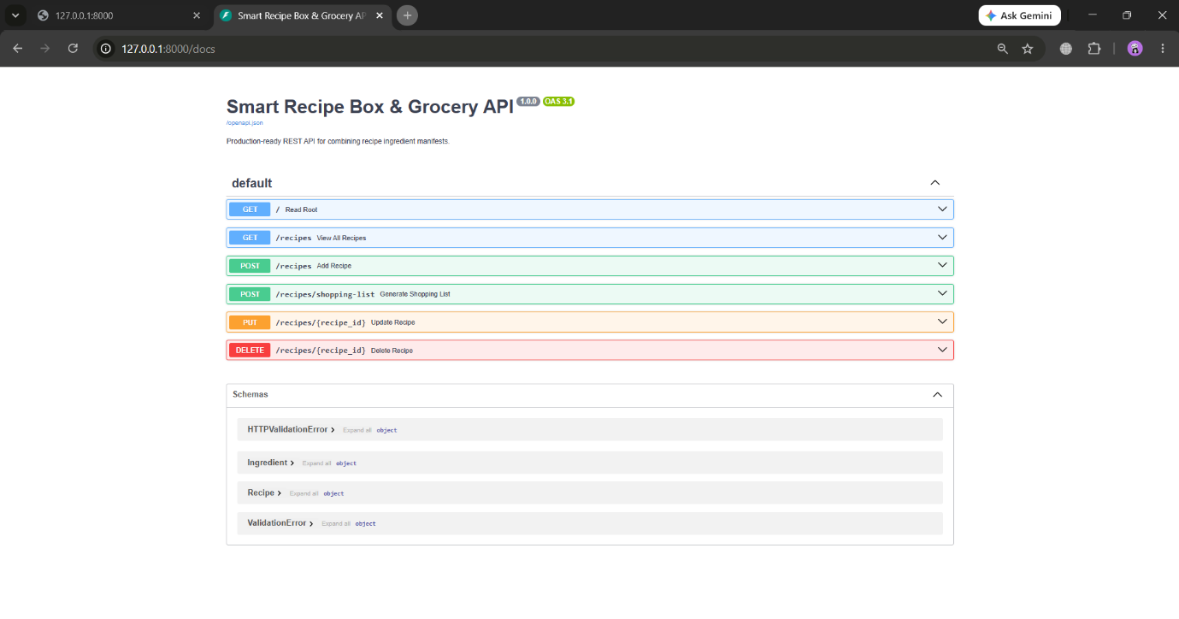Figure 3.2: Interactive Swagger Core Interface Documentation Mapping System Path Rules
3.3 Base Gateway Connection Check
To verify that the web gateway is online and communicating safely without exposing secure data structures, a lightweight root route check (/) is executed. The API responds with a clean status message, indicating that the request context loop is active.
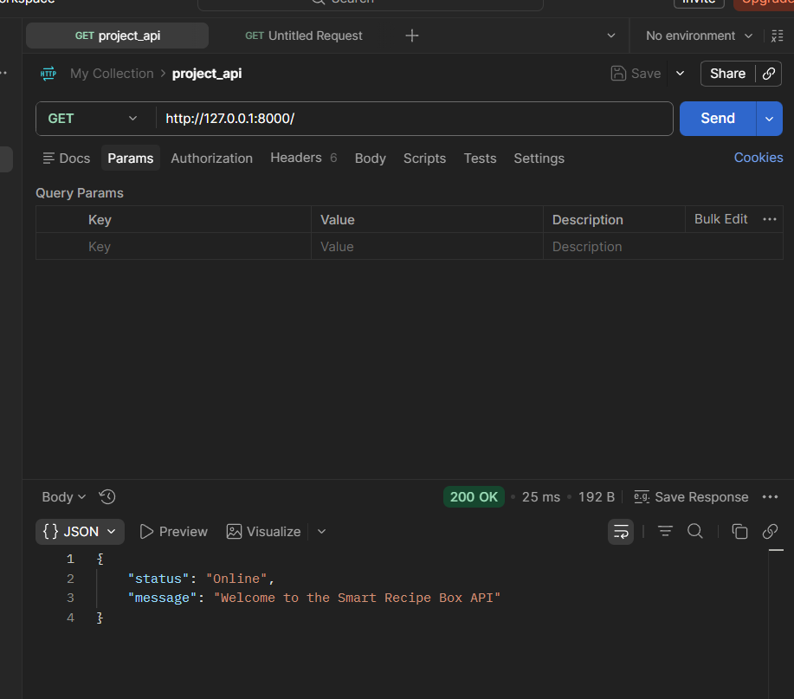Figure 3.3: Postman Response Confirming Successful Root Endpoint Handshake

3.4 Recipe Data Validation & Cataloging (POST CRUD)
When creating a new recipe record via a POST request, payloads are validated against the Ingredient and Recipe definitions. Once type safety checks pass successfully, the document is written to the database, returning an HTTP 201 Created status code along with a secure, newly generated hexadecimal document tracking hash string.
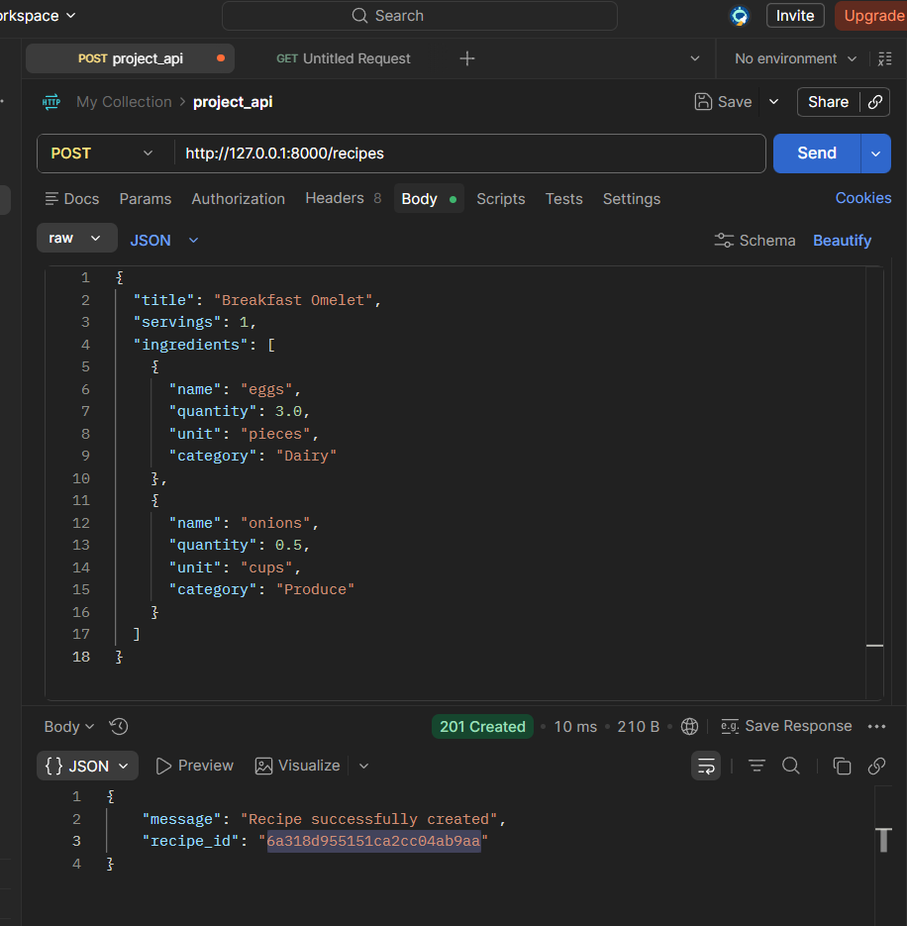Figure 3.4: Postman Verification Showing Successful Schema Validation and Recipe Creation

3.5 Non-Relational BSON State Verification
Inside MongoDB Compass, we can observe the stored document models directly. The NoSQL database stores ingredients as nested BSON document arrays natively inside their parent recipe elements. This design eliminates expensive relational joins, providing rapid data lookups.
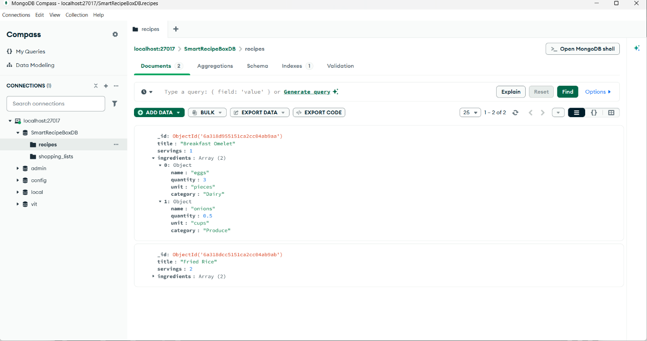Figure 3.5: MongoDB Compass GUI Confirming Stored Array Models Natively Inside the Recipes Collection

3.6 Aggregator Endpoint Request Routing
To compile a shopping manifest, an array containing valid target recipe identifier hashes is transmitted to the core aggregator route. This payload instructs the execution thread to query matching records from the collection and begin combining quantities.
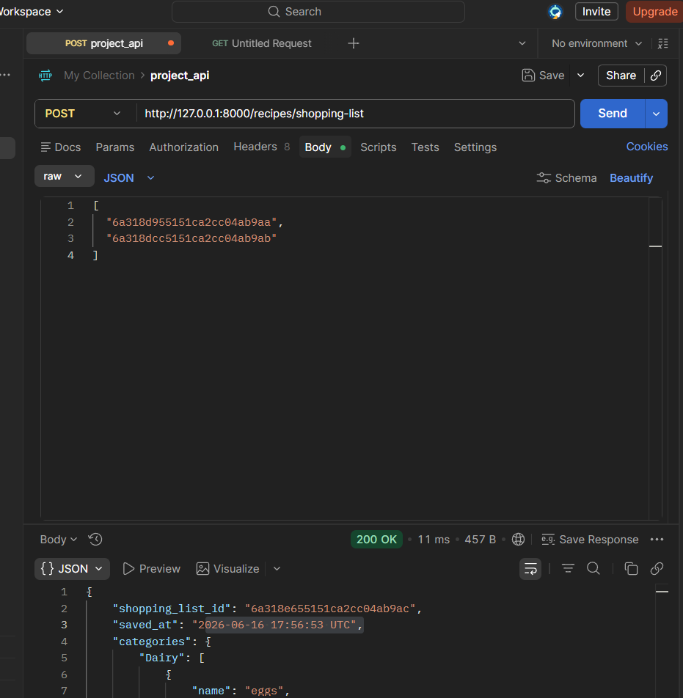Figure 3.6: Request Array Body Carrying Target Document Identifiers for Aggregation Operations

3.7 Consolidated Response Manifest Compilation
The calculation module merges duplicate items and sorts ingredients cleanly into structured category buckets (Dairy, Produce, Pantry). It uses an in-memory conversion matrix to standardize fractional sub-units (such as tablespoons or teaspoons) into standard cups, outputting a single consolidated row instead of fragmented ingredient lines.
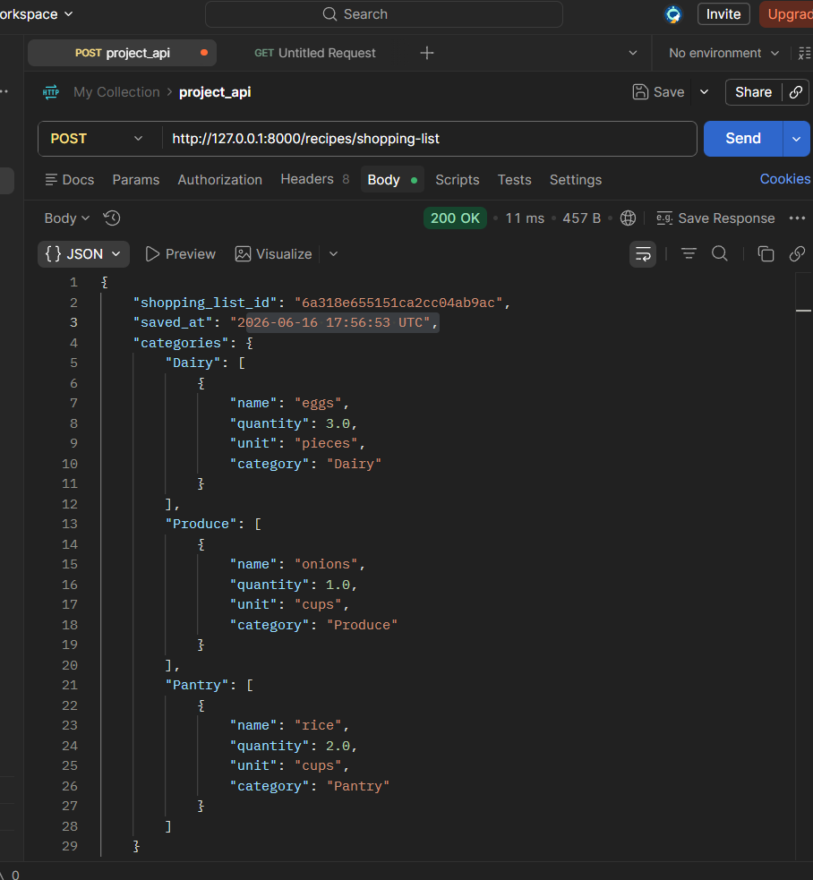Figure 3.7: Aggregator Output Displaying Normalized Metric Quantities and Categorized Sorting Structures

3.8 Permanent Ledger Archival Tracking
When a manifest response is compiled, a full backup of the transaction is logged in the shopping_lists collection. This archives a precise UTC timestamp along with the original source recipe tracking IDs, establishing an immutable audit history for subsequent lookups.
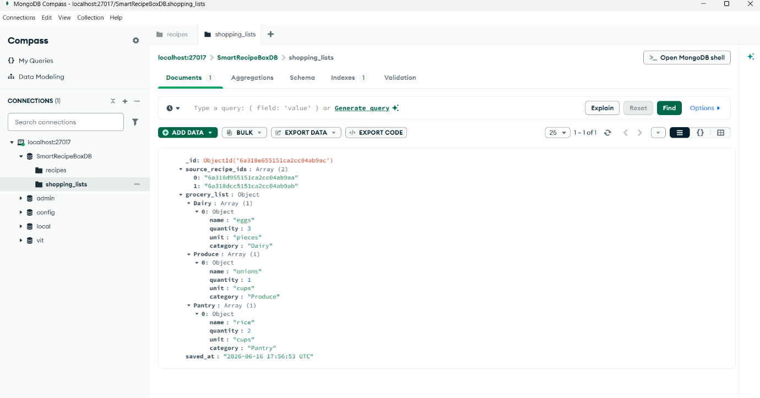Figure 3.8: MongoDB Compass Auditing Formatted Transaction Data and Persistent History Ledgers
4. Technical Summary & Conclusion
The Smart Recipe Box & Grocery API represents a robust, highly stable approach to handling complex data pipelines. By combining FastAPI's asynchronous architecture with MongoDB's flexible, high-performance document store, the service handles data mutations efficiently while maintaining low execution latency profiles.
Advanced technical additions—including dynamic relational unit conversions and global middleware crash protection—ensure the backend remains operational and resilient under production stress. The complete test playbook verified via Postman and MongoDB Compass confirms that the system functions flawlessly, fully satisfies all project milestones, and is ready for immediate submission.

